**DOCUMENTATION OF MY SETUP**

1. **DOWNLOADING A SUITABLE OPERATING SYSTEM**

* Go to https://www.microsoft.com/software-download/windows11 and click on the Download now button for Windows 11 Installation Assistant.
* Go to Downloads or your default path for downloaded items and locate your .exe file and run it as an administrator.
* Once the tool confirms the device hardware is compatible, you will be presented with the license terms. Select Accept and Install.
* Click the Restart Now button to complete installation on your computer and make sure that the PC is not turned off during the restart process.

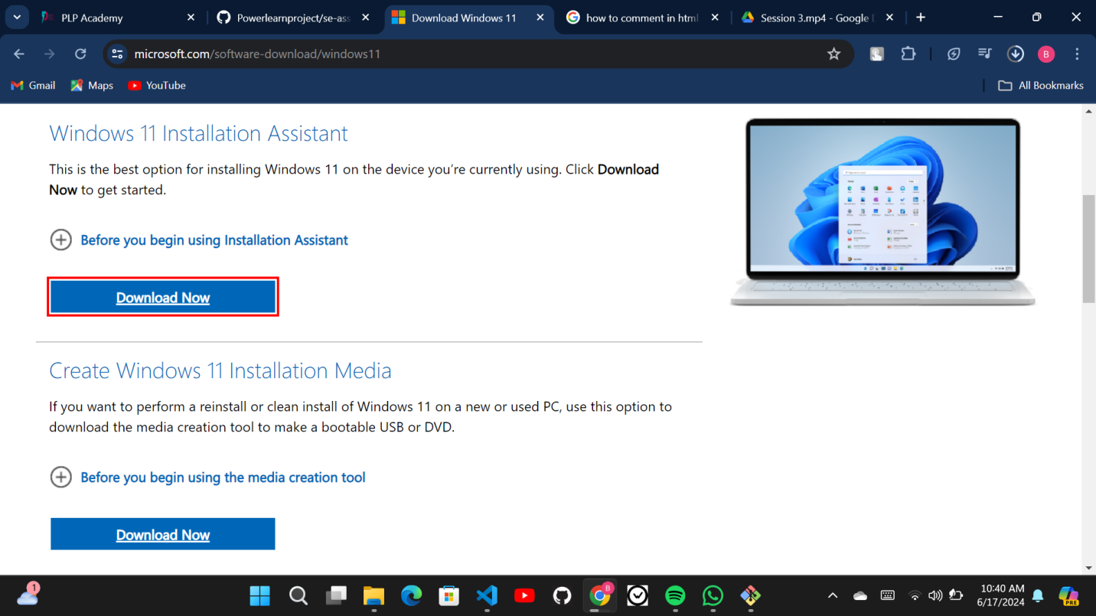

1. **INSTALLING VS CODE**

* Go to https://code.visualstudio.com/Download and click on the Download button on your top right corner or click on the Windows button if you are using Windows and the same for other OS.

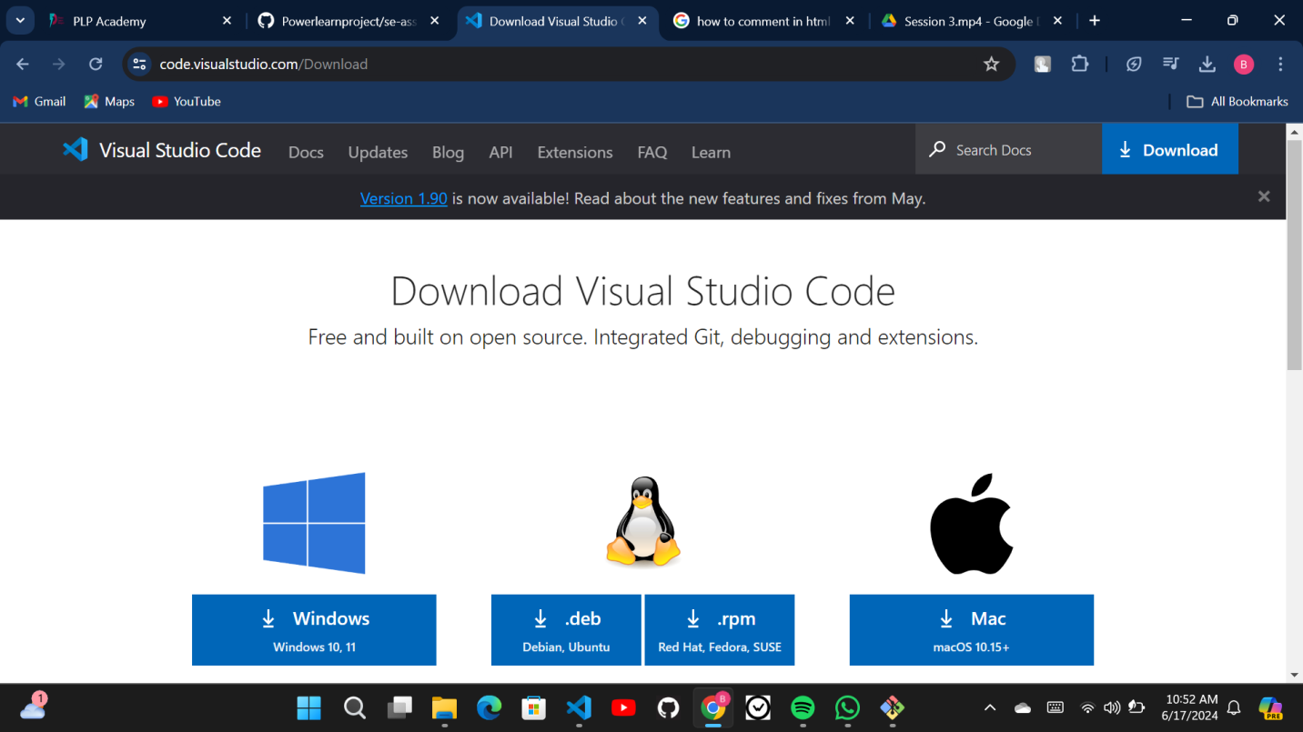

* Once it is downloaded got to downloads and locate the VS Code installer, click on it to run the installer.

C:\Users\Beryl\Pictures\Screenshots\Screenshot 2024-06-17 124505.png

* By default, VS Code is installed under C:\Users\{Username}\AppData\Local\Programs\Microsoft VS Code.

1. **INSTALLING AND CONFIGURING GIT**

* Go to https://www.git-scm.com/download/win to download git for windows and click on "Click here to download" and install.

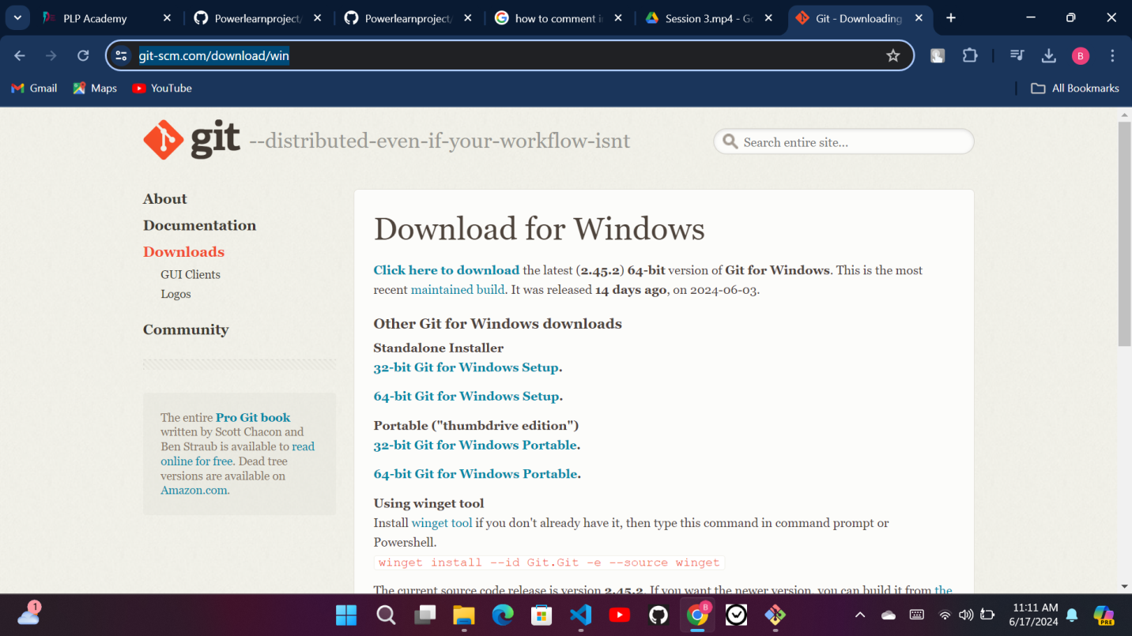

* Set up your username by running the git bash terminal and typing the following command, git config --global user.name "Nambwa04" (It should be the same username that you'll use on your github account)
* Set up your email by typing this command on the git bash terminal, git config --global user.email "bnambwa@kabarak.ac.ke"(It should be the same email that you'll use on your github account)

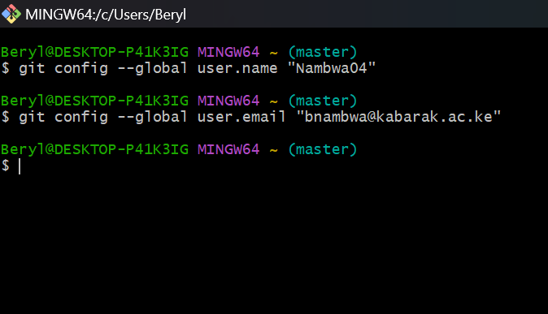

* To create a github account, visit https://github.com then select SIGN UP and use the credentials that you used to set up your git.

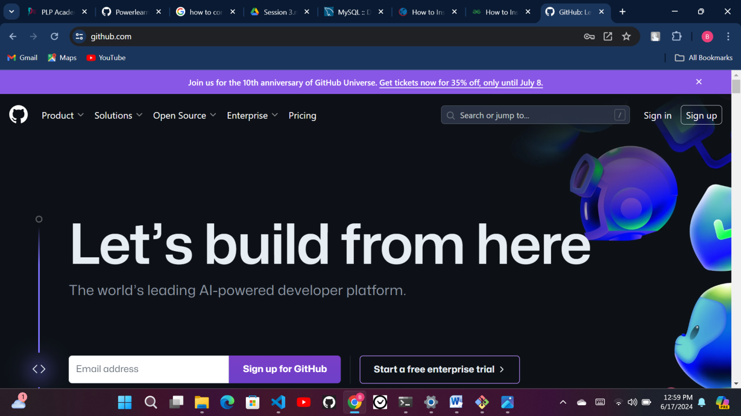

* To create a new repository, open the gitbash terminal, navigate to the directory of your project and type the following commands; git init (To initialise your repository) then press enter; git add . (Adds the files in the local repository and stages them for commit.) and press enter finally git commit -m 'Your message' (Commits the tracked changes and prepares them to be pushed to a remote repository.)
* Go to your github account and create a new repository and clone it.

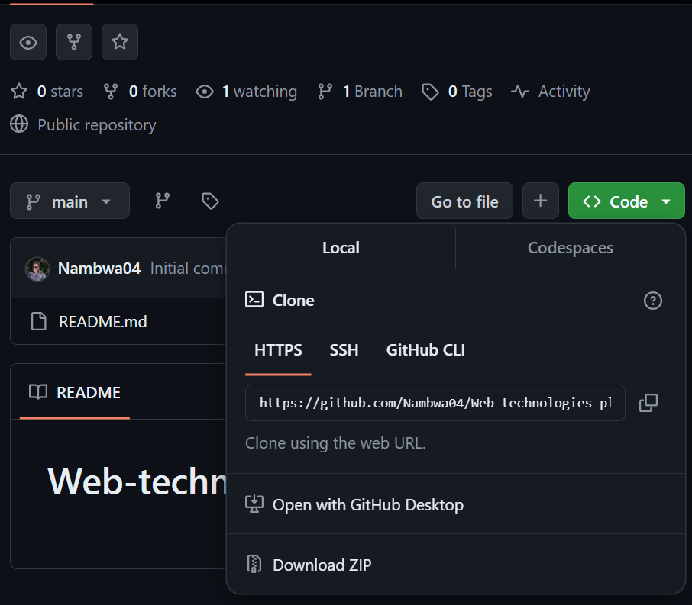

* On your gitbash, run the following command git remote add origin "link copied" then press enter.
* Then git push -u origin master to push the files to your repository.

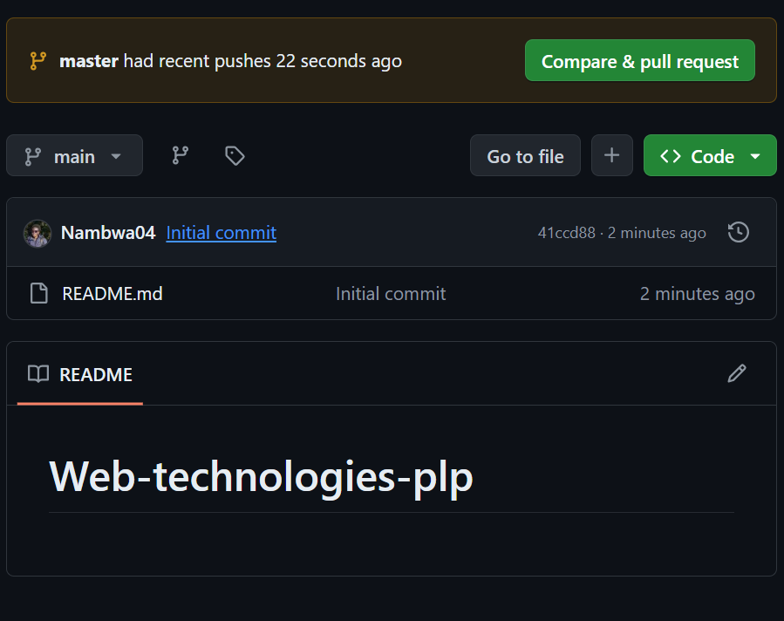

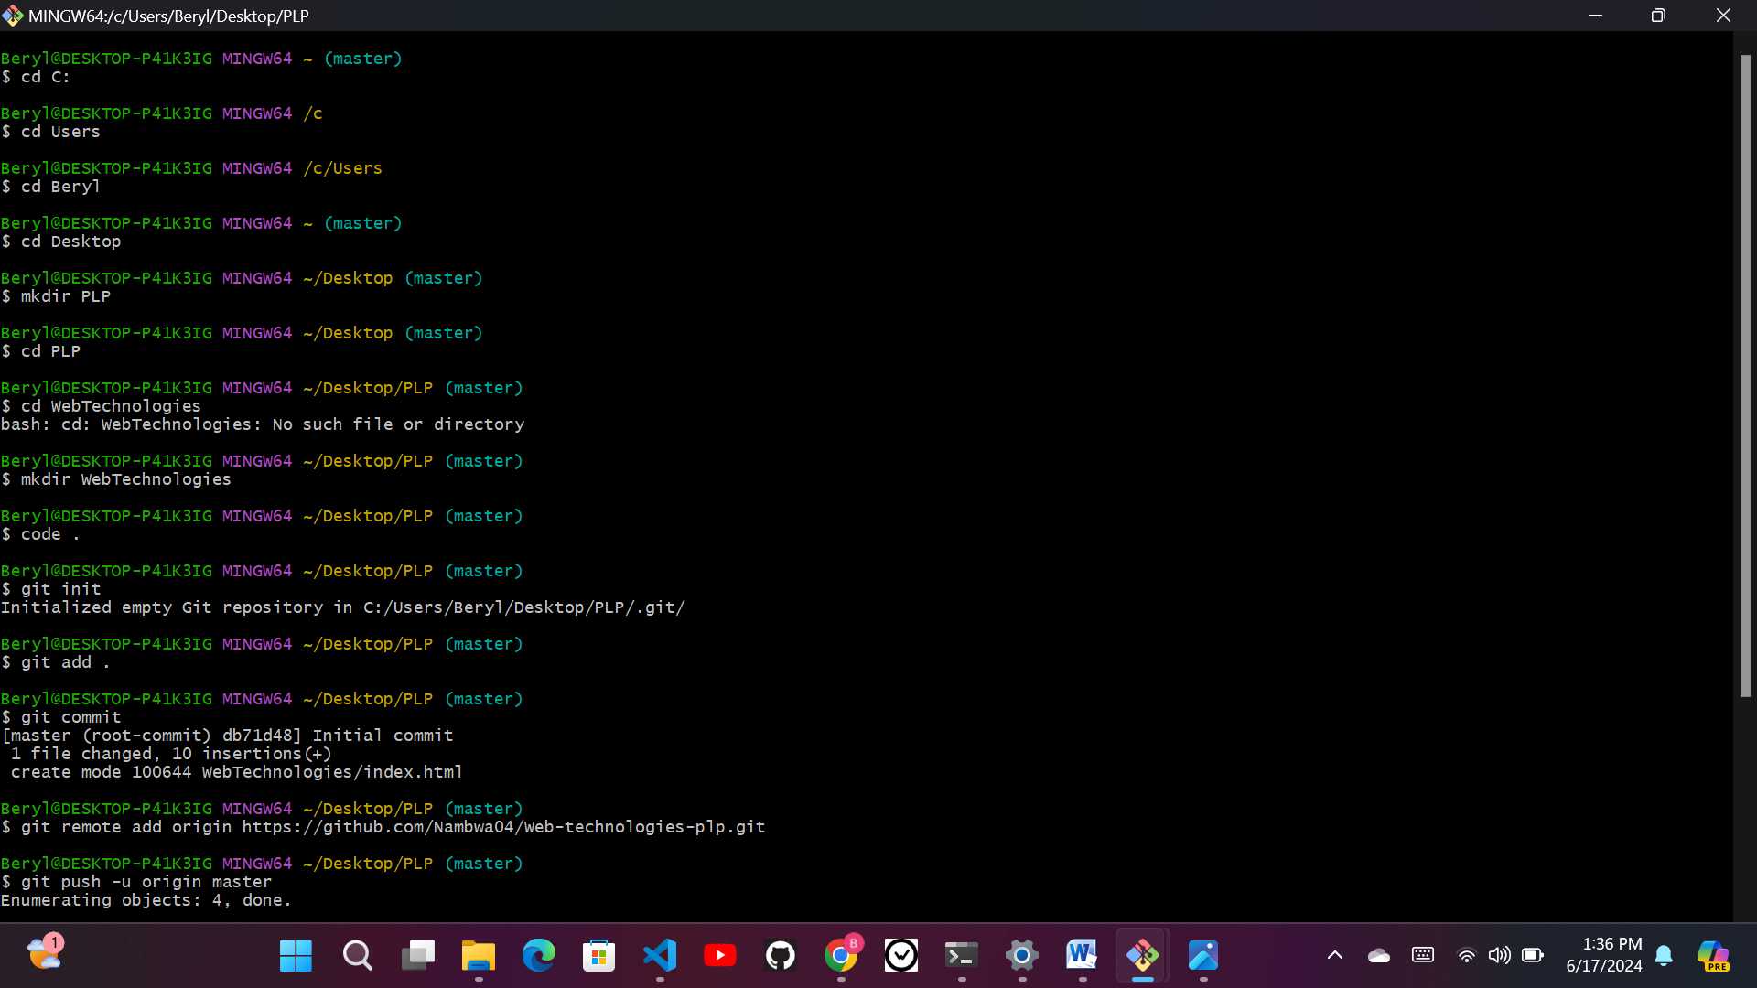

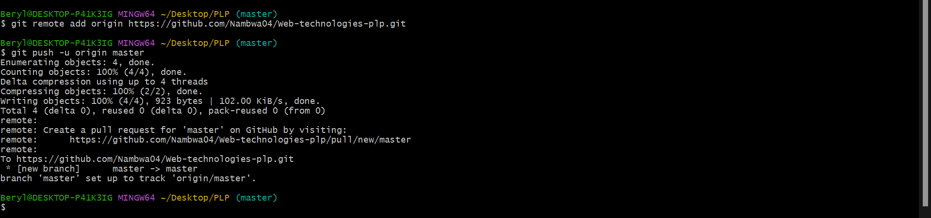

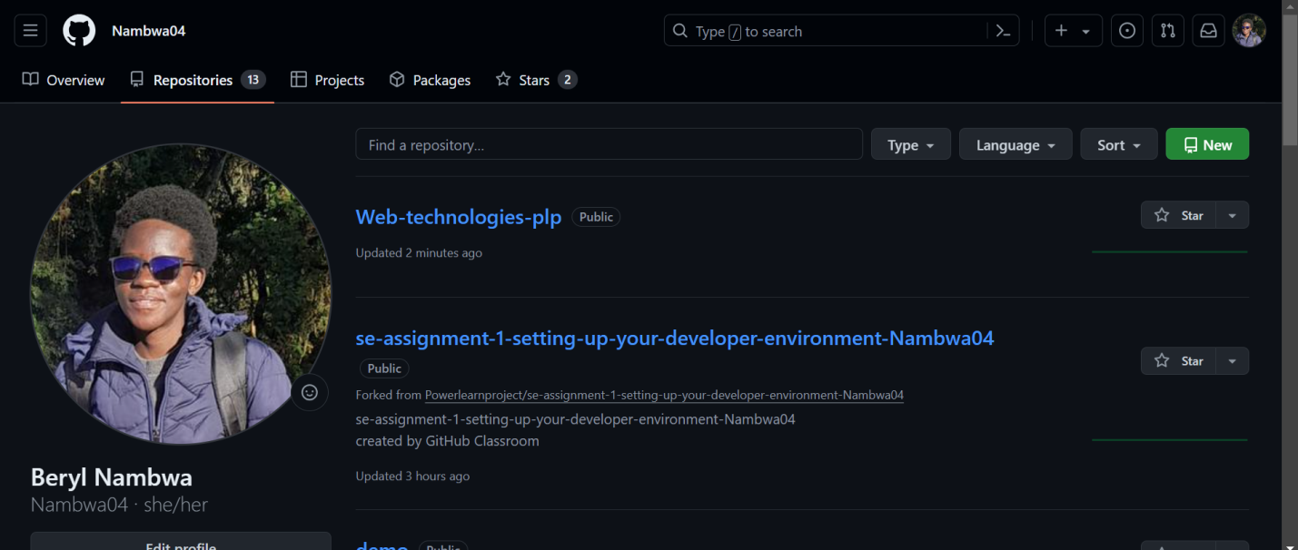

1. **INSTALLING PYTHON**

* Go to https://www.python.org/ and go to downloads.

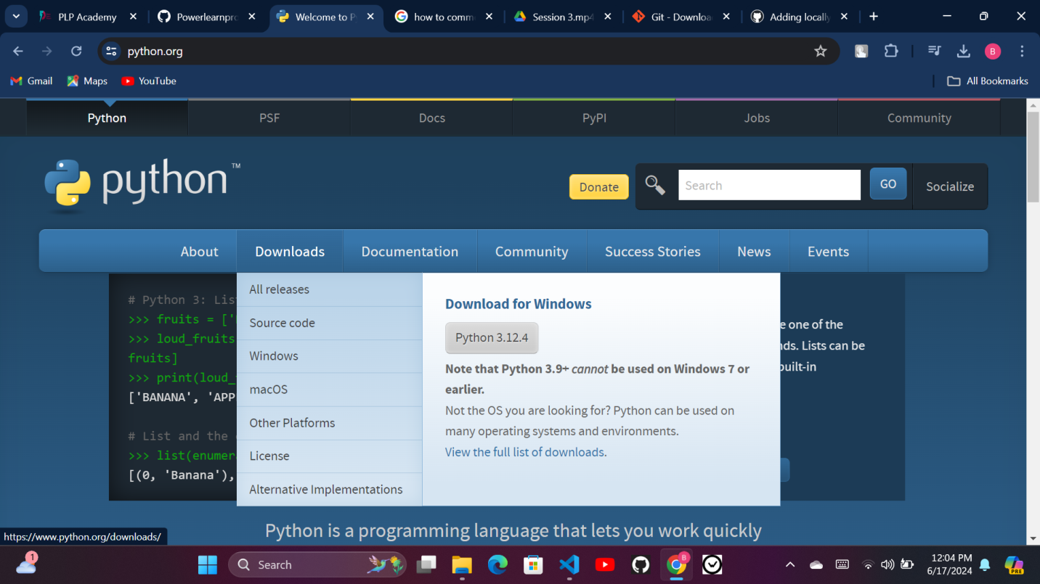

* Click on the "Python 3.12.4" button to download the installer.

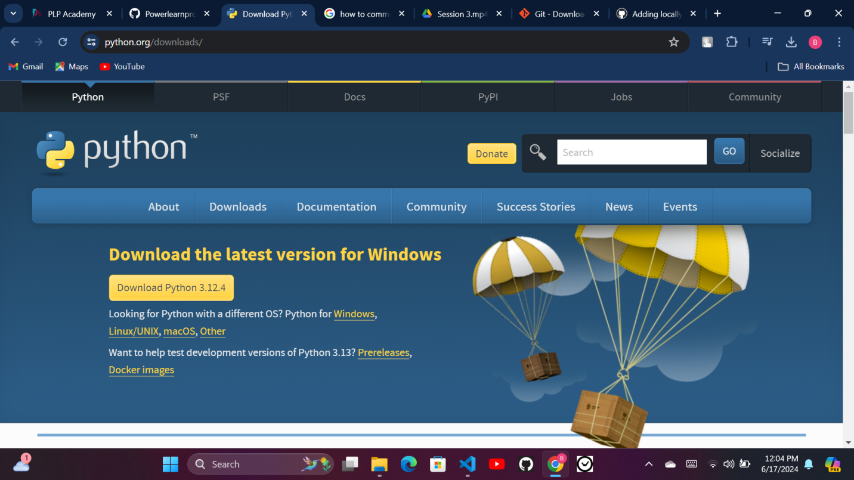

* Go to your downloads and locate the installer.
* Click on it to install Python.
* To check that python is install correctly, go to your cmd and type this command, python --version. It should display the version of the python you installed.

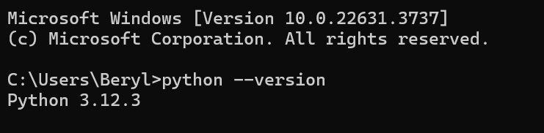

*I had already installed python

1. **INSTALLING PIP**

* To install pip, go to your command prompt and type this command, python -m pip install pip.
* To check if pip is installed correctly, run this command on your command prompt, pip –version.



*I had already installed pip

1. **CONFIGURING A DATABASE(MYSQL)**

* Go to https://dev.mysql.com/downloads/installer/ and select the (mysql-installer-community-8.0.37.0.msi and download)

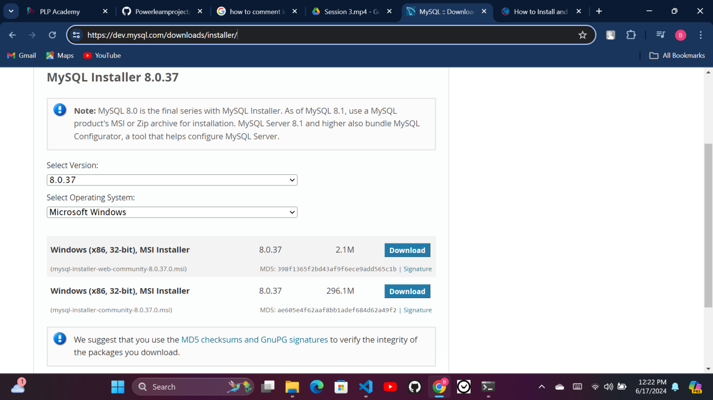

* Follow the steps in <https://phoenixnap.com/kb/install-mysql-on-windows> to install the mysql database.

1. **INSTALLING THE EXTENSIONS**

* Go to your VS Code and click on the extensions icon to your left.
* Search for the extension you desire to install.

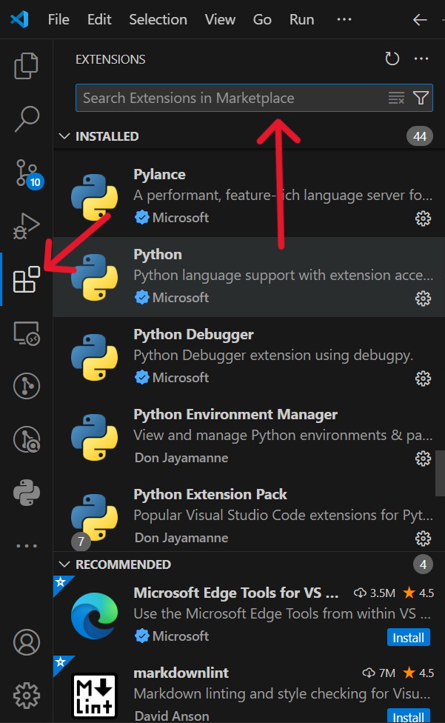

* Click the “Install” button.

